Internship Project Report

Project Title:
AI-Powered Financial Fraud Detection System Using Machine Learning

Submitted By:

Name: Anushkaa Mishra
Internship: IBM-PBEL(GENERATIVE-AI) (BATCH-3)
Technology Used: Python, Machine Learning, Streamlit
Submission Date: 18/07/2026

Acknowledgement

I sincerely thank my internship mentor and organization for providing me with the opportunity to work on this project. I also thank my teachers for their support and guidance throughout the completion of this project.

Abstract

Financial fraud has become one of the biggest challenges in online banking and digital payment systems. Millions of transactions occur every day, making it difficult to manually identify fraudulent activities.

This project develops an AI-powered financial fraud detection system using Machine Learning. The Random Forest algorithm is trained on historical credit card transaction data to classify transactions as genuine or fraudulent. A Streamlit-based web interface allows users to enter transaction details and instantly receive predictions.

The system helps reduce financial losses by automatically detecting suspicious transactions.

Introduction

Artificial Intelligence is transforming the banking industry by improving security and reducing fraud. Machine Learning algorithms learn patterns from historical transaction data and predict whether a new transaction is genuine or fraudulent.

The objective of this project is to build an intelligent fraud detection system that automatically classifies financial transactions.

Problem Statement

Financial institutions process millions of transactions daily.
Manual fraud detection is:
- Time-consuming
- Expensive
- Prone to human error
An AI-based automated fraud detection system is required to detect fraudulent transactions quickly and accurately.

Objectives

- Develop an AI-based fraud detection system.
- Train a Machine Learning model using transaction data.
- Predict fraudulent transactions.
- Build an easy-to-use web interface.
- Improve transaction security.

Technology | Technologies Used  Purpose
Python | Programming Language
Pandas | Data Processing
Scikit-learn | Machine Learning
Joblib | Model Saving
Streamlit | Web Interface
VS Code | Development Environment

Dataset
Dataset Name:
Credit Card Fraud Detection Dataset
The dataset contains:
- Time
- Amount
- V1 to V28 anonymized features
- Class
Class Values:
- 0 → Genuine Transaction
- 1 → Fraudulent Transaction figure 1 Dataset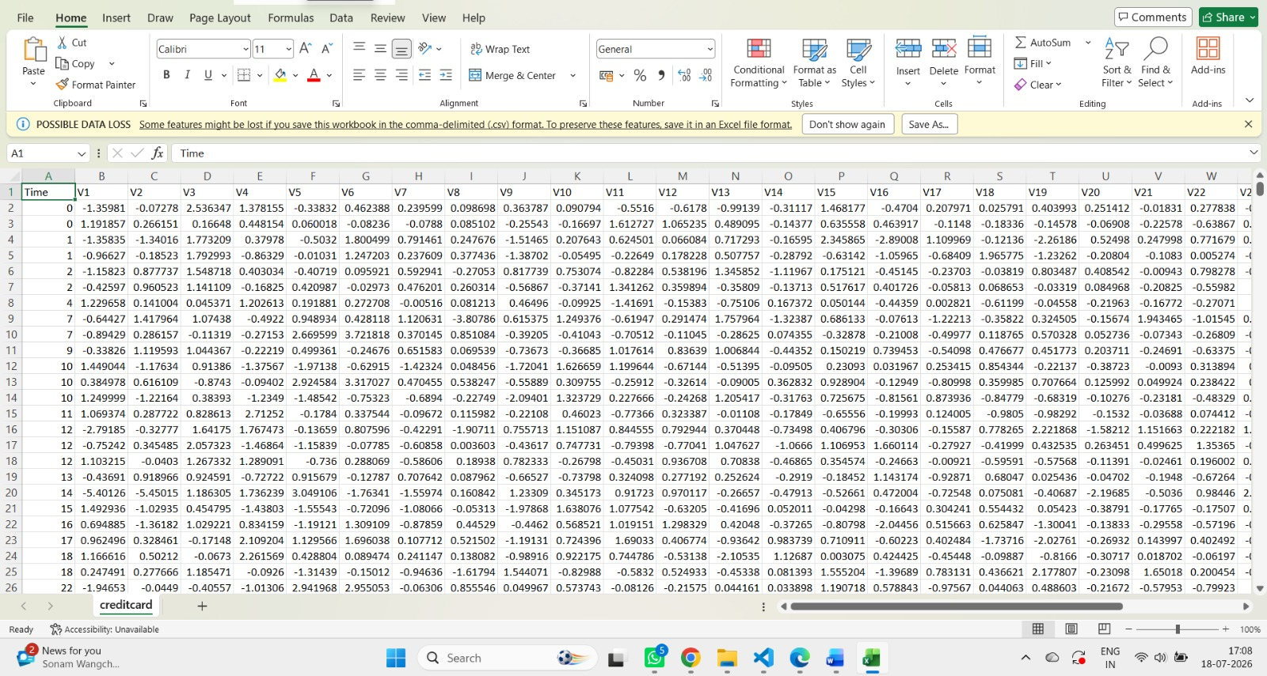

Machine Learning Algorithm
Random Forest Classifier
Random Forest is an ensemble learning algorithm.
It creates multiple decision trees and combines their predictions.
Advantages:
- High Accuracy
- Fast Prediction
- Handles Large Data
- Reduces Overfitting
System Architecture

Transaction Data
↓
Data Preprocessing
↓
Feature Selection
↓
Random Forest Training
↓
Save Model (.pkl)
↓
Streamlit Web Application
↓
Prediction
↓
Fraud / Genuine

Project Workflow
- Load Dataset
- Clean Data
- Split Dataset
- Train Random Forest
- Save Model
- Load Model
- User Enters Transaction
- AI Predicts Fraud

Implementation

Data Loading
The dataset is loaded using Pandas.

Figure 2: Dataset Loading in train.py

↓

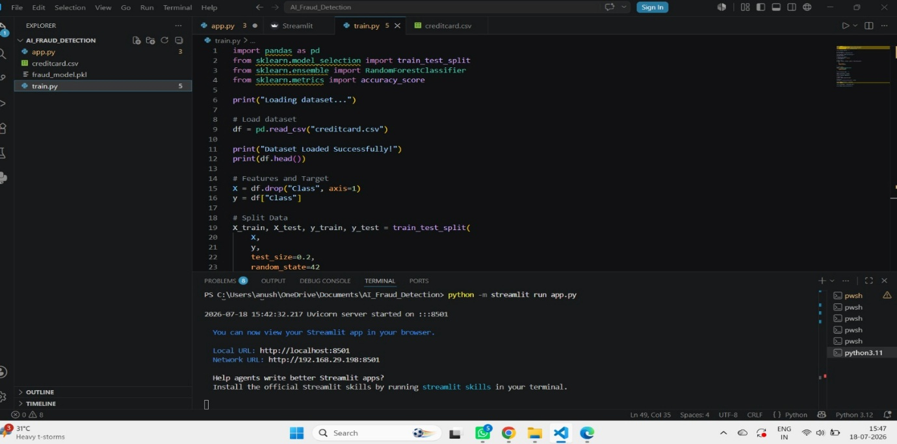
Model Training
Random Forest is trained using Scikit-learn.
Figure 3: Model Training Output
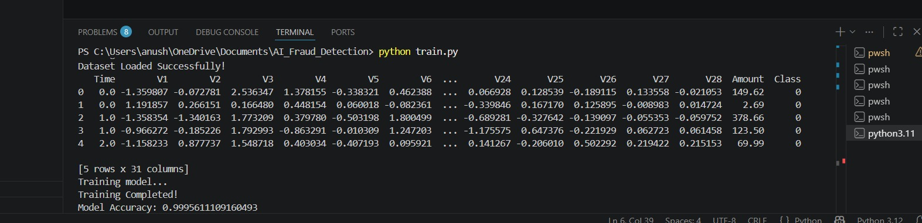
Model Saving
The trained model is saved as:
fraud_model.pkl
Web Application
A Streamlit interface collects transaction details and predicts fraud.
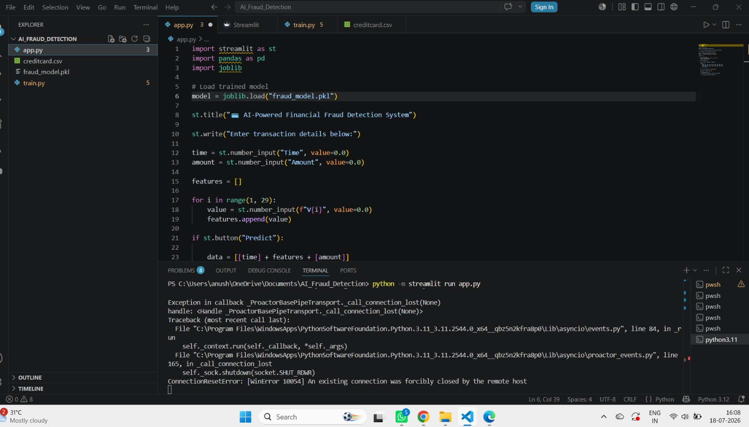

Results
The AI system successfully predicts transactions.
Example Output:
Prediction:
✅ Genuine Transaction

If fraud is detected:
🚨 Fraudulent Transaction Detected

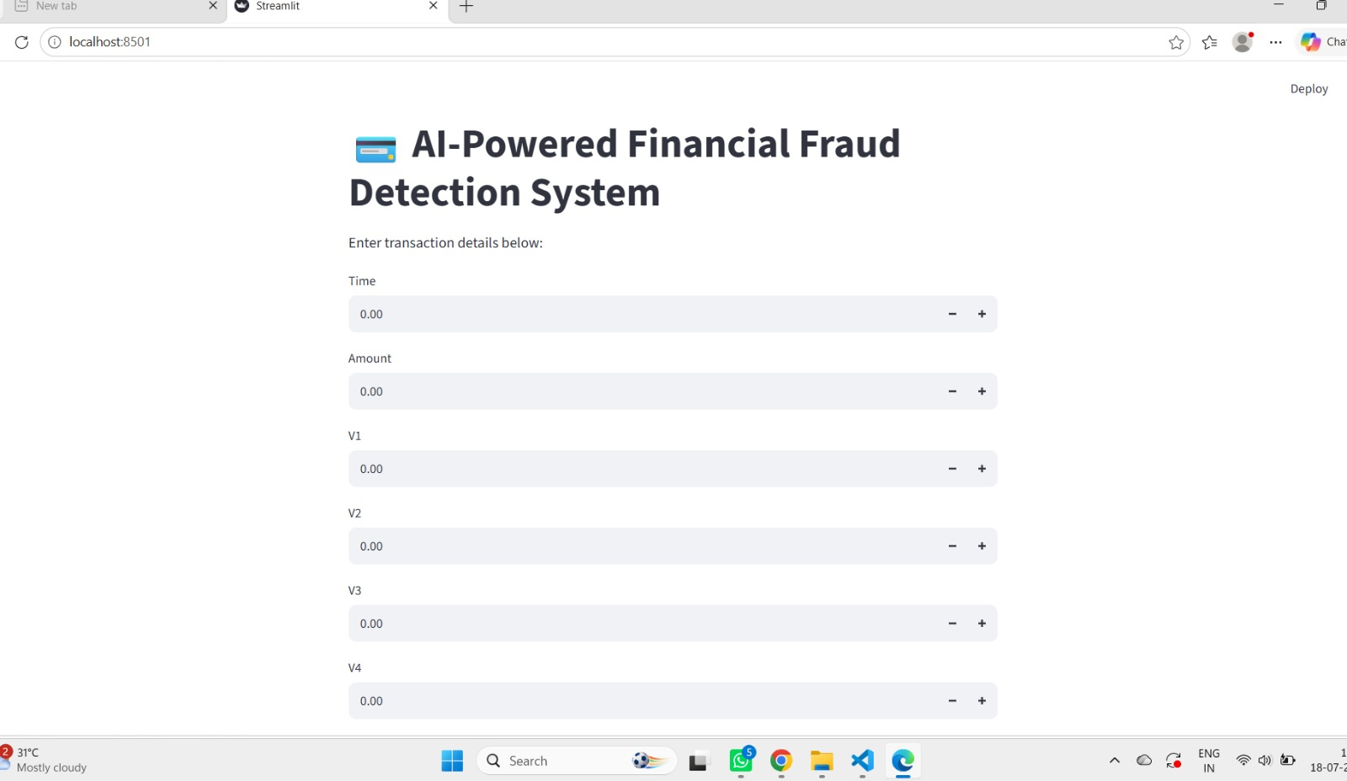

Advantages

- Fast Detection
- AI-Based Decision Making
- High Accuracy
- Easy User Interface
- Real-Time Prediction

Applications

- Banks
- Credit Card Companies
- Online Payments
- E-commerce
- Digital Wallets
- Financial Institutions

Future Scope

Future improvements include:
- Deep Learning models
- Live transaction monitoring
- SMS alerts
- Cloud deployment
- Real-time fraud detection
- Mobile application

Conclusion

The AI-powered financial fraud detection system successfully classifies financial transactions using Machine Learning. The Random Forest algorithm accurately predicts fraudulent activities, while the Streamlit interface provides an easy way for users to interact with the model. This project demonstrates how Artificial Intelligence can improve financial security and reduce fraud.

References

- Scikit-learn Documentation
- Python Official Documentation
- Pandas Documentation
- Streamlit Documentation
- Credit Card Fraud Detection Dataset (Kaggle)

